Green Power Smoothie
Ingredients:
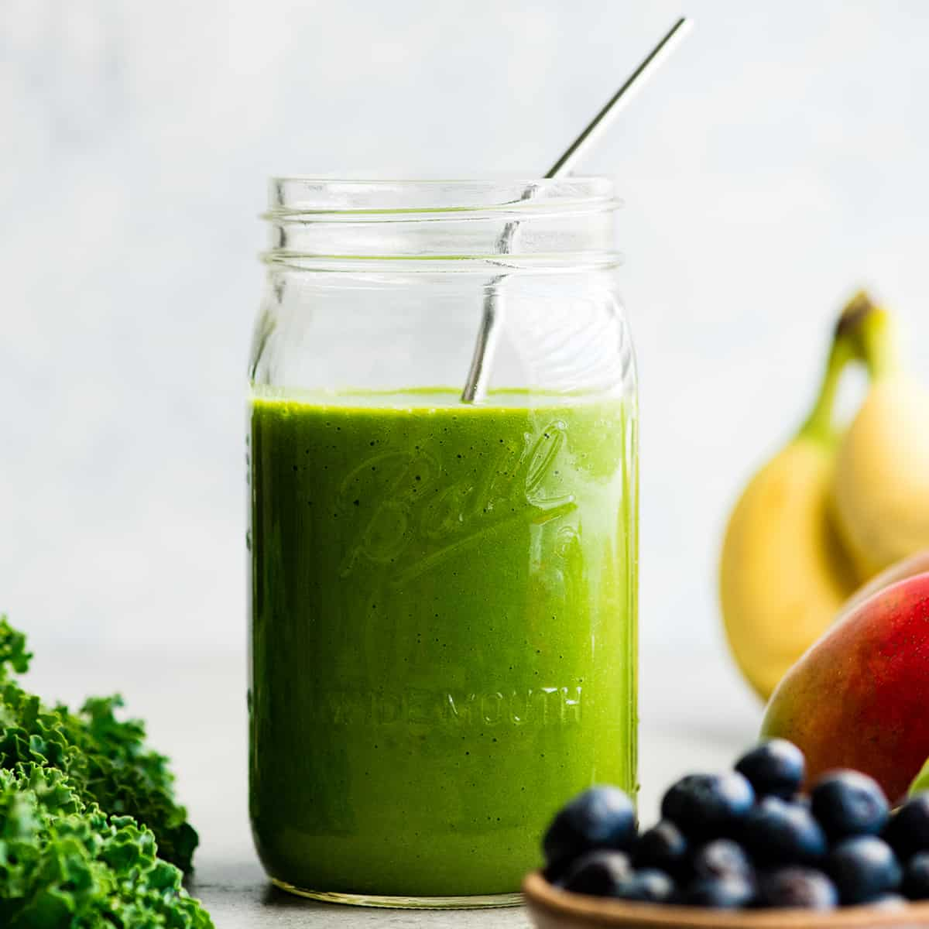
- 3-4 cups spinach or other greens
- 1 cup unsweetened vanilla almond milk
- Handful of ice cubes
- ½ of a frozen banana
(you can peel, cut ripe bananas in ½, freeze)
- ½ cup of frozen berries
- A little more water? About 8 oz more
- 1 ½ T ground flax seed, ½ T chia seeds

Directions:
Blend for at least 2-3 minutes. Great for breakfast or refrigerate and sip on it during the day, have it around lunch time, etc.

www.drserna.com
info@northcypresswellness.com
(281)807-5300

