Simple Black Bean and Pinto Salad

Ingredients
- 1 cup cooked black beans and 1 cup cooked pinto beans
(if using canned, look for low sodium option, drain and rinse)

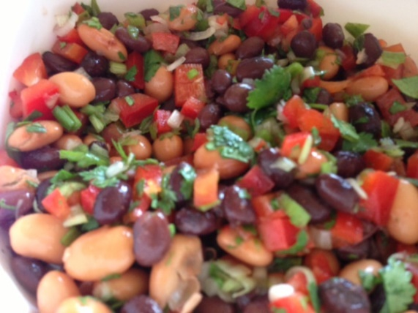
- 1 cup diced red bell pepper
- ½ cup minced green onion

- ¼ tsp cayenne pepper

- 2 tbsp red wine vinegar

- 1 tbsp lemon juice

- 2 tbsp minced cilantro

Instructions
Combine all ingredients and refrigerate for one hour prior to serving. Refrigerate leftovers.

www.drserna.com
info@northcypresswellness.com
(281)807-5300
Source: Patient Submission

